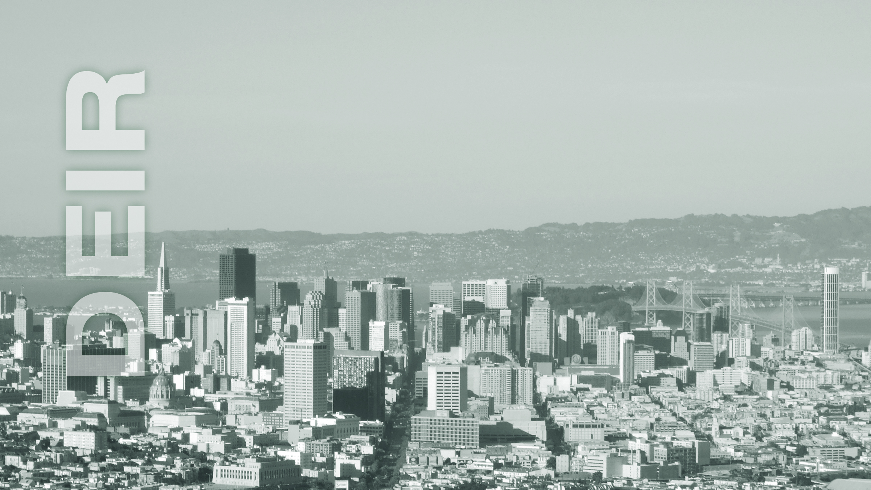



*Written comments should be sent to:*

Sarah B. Jones Environmental Review Officer | 1650 Mission Street, Suite 400 | San Francisco, CA 94103

or Bill.Wycko@sfgov.org

|  |  |  |
| --- | --- | --- |
| Administrative  Draft Number **01** | Draft EIR Publication Date: | **MONTH XX, 20XX** |
| Draft EIR Public Hearing Date: | **MONTH XX, 20XX** |
| Draft EIR Public Comment Period: | **MONTH XX, 20XX - MONTH XX, 20XX** |

[Project Address/Title]

PLANNING DEPARTMENT   
CASE NO. **[20XX.XXXXE]**

STATE CLEARINGHOUSE NO. [xxxxxxxxxx]

**DRAFT ENVIRONMENTAL IMPACT REPORT**

